**LAB # 09**

**Task #1: Create an application named DebugConsole having the following UI:**

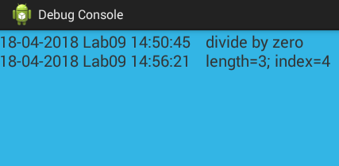

**Solution:**

**Design:**

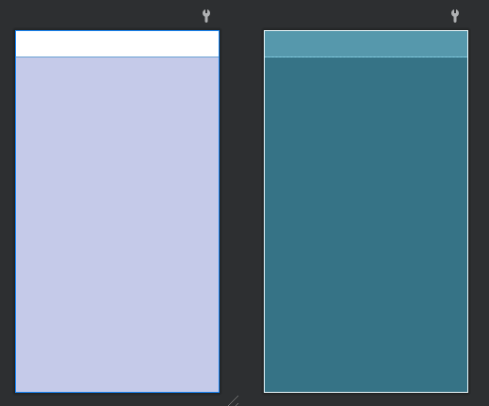

**Code:**

**MainActivity Class:**

public class MainActivity extends AppCompatActivity {

private DebugBroadcastReceiver debugReceiver;

private TextView debugTextView;

@Override

protected void onCreate(Bundle savedInstanceState) {

super.onCreate(savedInstanceState);

setContentView(R.layout.activity_main);

debugTextView = findViewById(R.id.debugTextView);

debugTextView.setMovementMethod(new ScrollingMovementMethod());

debugReceiver = new DebugBroadcastReceiver(debugTextView);

IntentFilter intentFilter = new IntentFilter("DEBUG_INFO");

registerReceiver(debugReceiver, intentFilter); }}

**DebugBroadcastReceiver Class:**

public class DebugBroadcastReceiver extends BroadcastReceiver {

private TextView debugTextView;

public DebugBroadcastReceiver(TextView debugTextView) {

this.debugTextView = debugTextView;

}

@Override

public void onReceive(Context context, Intent intent) {

if (intent.getAction() != null && intent.getAction().equals("DEBUG_INFO")) {

String date = intent.getStringExtra("date");

String appName=intent.getStringExtra("appName");

String time=intent.getStringExtra("time");

String message = intent.getStringExtra("message");

String text = date+" "+appName+" "+time+"\t"+ message +"\n";

debugTextView.append(text);} }}

**Output (Before Getting MSG):**

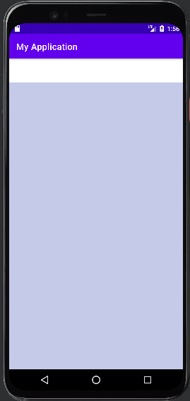

**Task #2: Create an application which can send broadcast to the DebugConsole (above application). You may use the following UI as reference:**

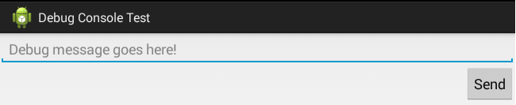

**On pressing send button a broadcast with action DEBUG_INFO must be send to the system. That broadcast must contain application name as well as message, given by user, to be displayed on DebugConsole.**

**Solution:**

**Design:**

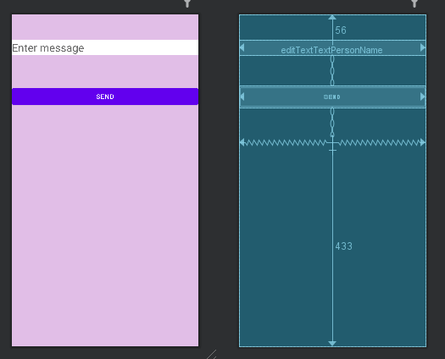

**Code:**

**MainActivity.java:**

public class MainActivity extends AppCompatActivity {

private EditText messageEditText; private Button sendButton; private TextView textView;

@Override

protected void onCreate(Bundle savedInstanceState) {

super.onCreate(savedInstanceState);

setContentView(R.layout.activity_main);

messageEditText = findViewById(R.id.editTextTextPersonName);

sendButton = findViewById(R.id.button);

textView=findViewById(R.id.textView);

sendButton.setOnClickListener(new View.OnClickListener() {

@Override

public void onClick(View v) {

String message = messageEditText.getText().toString();

Date currentTime = new Date();

SimpleDateFormat timeFormat = new SimpleDateFormat("HH:mm:ss");

String formattedTime = timeFormat.format(currentTime);

System.out.println("Current time: " + formattedTime);

Date currentDate = new Date();

SimpleDateFormat dateFormat = new SimpleDateFormat("yyyy-MM-dd");

String formattedDate = dateFormat.format(currentDate);

System.out.println("Current date: " + formattedDate); messageEditText.setText("");

textView.setText("Message Sent"); Intent intent = new Intent("DEBUG_INFO");

intent.putExtra("message", message);

intent.putExtra("date", formattedDate);

intent.putExtra("time", formattedTime); intent.putExtra("appName", "My Application"); sendBroadcast(intent); } }); }}

**Output (Before Sending MSG):**

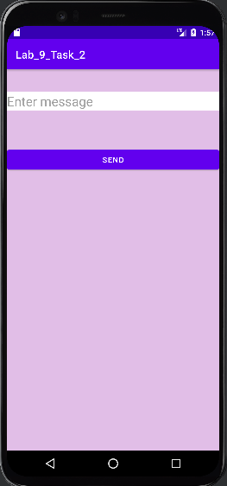

**Output of Both apps After Sending msg:**

